Pebworth Parish Council
Minutes of the Ordinary Parish Council Meeting held
At the Village Hall, Pebworth on Monday 6th November 2023

Present: Councillors: Richard Weller (Chairman), Simon Shiers, James Pearson, Sam Parkins, David Cranage & Jodi Cotton
In attendance: Judith Ciotti, Mrs D Bowles (Clerk)

Also in attendance: 4 members of the public.
Apologies Considered for Absence:
None
Register of Interests:
Disclosures of Interests:
Members were reminded of the need to keep their register of interests updated. Members were asked to
declare any Disclosable Pecuniary or other Interests in items considered in virtual meetings and their nature.
Cllr Cotton – 8c
None declared
Open Forum: The Chairman suspended the formal meeting for the Ward Members and public participation.
- 4 members of the public were in attendance:
- Parking on the dropped kerb by the village hall has caused an issue for residents. Cllr Weller advised the resident to discuss this with the Chair of the Village Hall Committee reminding hall users to be considerate when parking.
- Query regarding planning application which is being discussed under agenda item 6a – resident is concerned regarding the impact on the reduced light to her property.
- Bollard outside Bank House on Front Street is missing. Clerk advised Members the Lengthsman Scheme is unhappy to pay for these works and they should be referred to Highways. Members resolved to pay for any bollard repair work going forward.
- Back Lane - overgrown ivy on a wall causing an issue with visibility. Clerk to write to landowner in the first instance.
- Potholes to be reported on the road from Little Meadows to Ullington crossroads
- Issues relating to Meon Way Gardens however these do not fall under the remit of the Parish Council.
- It was reported that the uptake to events at the village hall has risen. This is due to residents from Meon Way Gardens being more informed.
The Chairman closed the open forum and reconvened the meeting at 19:30
Ward Member’s Report:
- County Councillor Adams – apologies and report received (Appendix B)
- District Councillor Ciotti:
- Planning Communities Together event being held on 23rd November 6.30pm. All Cllrs invited.
Acceptance of Minutes:
The Minutes of the Ordinary Parish Council Meeting held on Monday 2nd October 2023 at the Village Hall, Pebworth were considered and approved by the Council to be a true record of the meeting and were signed by the Chairman.
Planning Matters:
Considered:
- W/23/02156/FUL Location: Elm View, Chapel Road, Pebworth, Stratford Upon Avon, CV37 8XJ Description of Proposal: Demolition of existing dwelling and construction of nine dwellings, creation of new vehicular access into site along with private driveways and gardens, alteration and extension of retained outbuilding at Elm View and alteration and extension of Walnut Tree Cottage. Following discussion, it was resolved to object to this application. Cllr Cranage to draft a response.
- W/23/02146/FUL Location: Old Granary, 1 Bank Farm Court, Front Street, Pebworth, Stratford Upon Avon, CV37 8XQ Description of Proposal: Change of Use of Highway Land to Private Garden (retrospective). Following discussion, it was resolved for Clerk to respond with “No comment”.
Considered between meetings:
- W/23/00985/HP Location: The Forge, Back Lane, Pebworth, Stratford Upon Avon, CV37 8XA Description of Proposal: A dilapidated, old stable building that is no longer used would be demolished and rebuilt into an outbuilding as a living space with one bedroom and a kitchen/living room area as open plan for extra accommodation for family use. Cllr Weller declared an interest and did not take part in the email discussion. Following consultation via email Clerk responded with “Pebworth Parish Council has no objection to this application however we do question whether the parking provision is sufficient for the increase in dwelling capacity created by the application as there is no capacity for parking on the street.”
- W/23/01124/FUL AMENDMENT Amended design of dwellings Demolition of existing agricultural barns and replacement with 5no. detached dwellings. Location: Bank Farm, Front Street, Pebworth, Stratford Upon Avon, CV37 8XQ. The Parish Council had no further comments to make on this application.
- W/22/01911/FUL AMENDMENT Full planning application for the demolition of agricultural buildings with Class Q consent and the erection of 5 dwellings. Location: New Buildings Farm, Priory Lane, Broad Marston, Pebworth. The Parish Council had no further comments to make on this application.
Decisions:
- W/23/01761/HP - Hobby workshop (part retrospective) Location: 14 Middlesex, Pebworth Road, Ullington, Pebworth, Stratford Upon Avon, CV37 8XF. Planning Application Refused.
- W/23/01404/HP - Hall extension and front porch Location: 8 Little Meadow, Pebworth Road, Ullington, Pebworth, Stratford Upon Avon, CV37 8XE. Application approved subject to conditions.
W/23/01136/HP Single-storey extension to rear, first-floor extension to side, new dormer windows and external alterations Location: Hill House, Pebworth Road, Ullington, Pebworth, Stratford Upon Avon, CV37 8XG. Application approved subject to conditions
Finance:
- Council noted the increase in employer’s pension contribution to 8% for year 3 as per the November 2021 minutes.
- The Council gave consideration and unanimous approval of the payments listed in Appendix A, confirming the payments in Appendix A have been approved by full Council and there is provision within the budget, and that financial regulations and relevant policies have been followed. Cllr Pearson to authorise the payments made by internet banking.
Council & Community Matters:
Considered:
- applying for the Community Legacy Grant, applications open in January – defer to December agenda.
- flooding issues in Friday St – Cllr Cranage to speak with County Cllr Adams with a proposed solution and to report back to the Parish Council at the December meeting.
- application received for £100 grant for Coffee on the Close. Cllr Cotton did not take part in the discussion. It was resolved to support this. Clerk to make payment to the Village Hall account.
- setting up a Community Grant application form and Terms and Conditions – defer to December agenda.
- responding to the questions relating to Worcestershire Local Flood Risk Management Strategy and the associated Surface Water Management Plan for the county (emailed 30.10.23.) Cllr Weller & Cllr Cranage will investigate and respond if necessary.
Members noted:
- the dropped kerbstones between 1 & 4 Chapel Rd have been approved.
- the gritting route has been extended to include Broad Marston Rd.
- a new keycode padlock has been installed on the gate to The Recreation Field.
- New dog bins have now been installed on Meon Way Gardens.
The Close & Recreation Field
- Members noted the tennis net has now been removed for the winter.
- It was resolved for the ditch to be cleared at The Close. Clerk has sought confirmation from Rooftop that they are willing to pay half the costs.
- Clerk has authorised the hedge cutting at The Recreation Field
- The zipwire repairs will take place on the mound
Allotments:
Members noted all allotment holders have been advised of the gate code for the new padlock.
Allotment plot number 10 has been leased.
Highway Matters:
- Clerk to re-contact Severn Trent Water regarding manhole cover opposite The Masons Arms
- Police Officer Alex Prentice has taken over from Matt Beards; she has spoken with the nursery regarding consideration when parking
Lengthsman/Handyman Matters:
- Signage clearance works have taken place
- Gully grates have been cleared at Broad Marston
Future Works:
Bollard on Front St to replace by Bank House
Repair works on zipwire mound to take place
VAS:
VAS data has been emailed to Members (Appendix C)
Matters Raised by Members: The following matters were raised by Council Members for consideration for future agendas:
- Cllr Weller will lay the wreath on Remembrance Day and Cllr Shiers is reading the poem.
- Budget meeting set for Tuesday 28th November 7pm.
Date of Next Meeting:
Council confirmed the date of the next Ordinary Parish Council Meeting on Monday 4th December 2023 at 7.00pm in the Village Hall, Pebworth.
Closure of Meeting: The Chairman closed the meeting at 21:00 hrs

Chairman: ______________________________________________Date:_________________

FINANCE

Verified & Confirmed Account Balances as at 9th October:

Treasurers Account | 2,405.17
Business Bank Instant | 37,298.20
Total | 39,703.37

APPENDIX A

PAYMENT | PAYEE | DETAILS | TOTAL | VAT | NET
BACS | HMRC | Clerk & P C Tax & NIC | **** |  | ****
BACS | Mrs D Bowles | Clerk's Salary & Expenses | **** |  | ****
BACS | John Hyde | Lengthsman Works | 87.80 |  | 87.80
BACS | Maurice Parkinson | Cemetery works | 396.00 | 66.00 | 330.00
BACS | Limebridge RS | Amenity Works | 588.00 | 98.00 | 490.00
BACS | K Pearson | Village Website domain | 23.96 | 3.99 | 19.97
BACS | K Pearson | Village Website hosting | 102.64 |  | 102.64
BACS | Eibe Play Ltd | Replacement parts | 73.82 | 12.30 | 61.52
DD | Nest | Clerk's Pension | 57.13 |  | 57.13
DD | Ionos | Email | 7.20 | 1.20 | 6.00
DD | O2 | Mobile Phone | 5.54 | 0.92 | 4.62
DD | Yu Energy | Streetlight Energy | 43.00 | 2.05 | 40.95
DD | Yu Energy | Streetlight Energy | 158.49 | 7.55 | 150.94

APPENDIX B – COUNTY COUNCILLOR REPORT

County Councillor Report – Pebworth
Month: November 2023
Prepared by Alastair Adams
Littletons Division, Worcestershire County Council

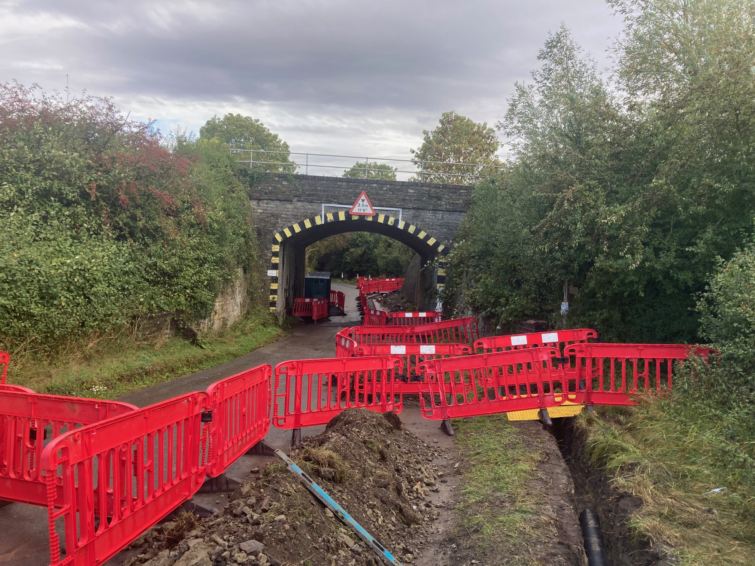
NEW drains under the Honeybourne Bridges should help alleviate the flooding
Honeybourne Rd was closed for 2 weeks in whilst WCC installed a new network of drains on the Honeybourne side and fitted large gullys to the existing drains. See photo below.

The good news, the new drains worked! On 19th & 20th October we had really the heavy rain and widespread flooding but there was little water under the bridges, and the road was still passable. So another flood alleviation scheme that has worked.

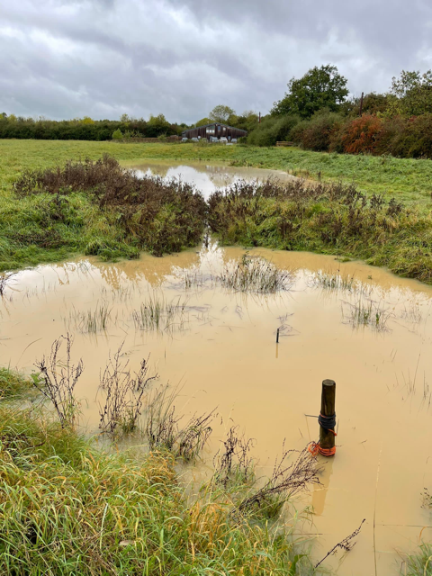
Other updates on flooding form 20/10/23
The flood plain in the Heart of England field on Mickleton Rd/Broad Marston Rd worked well on the 20th Octo 2023 following the excellent work carried out by the volunteers last month. The new channel worked well, and the flood plain filled – see photo below.

As a consequence, there was hardly any water under the Broad Marston/Holt railway bridge, and the road was still passable. So another flood alleviation scheme that has worked.

The Noleham brook was still very high on 20/10/23 as you can see from the photo below, and a little fine tuning to the inlets into the 2 x Flood plains may be needed. I will liaise with the Broad Marston volunteers.
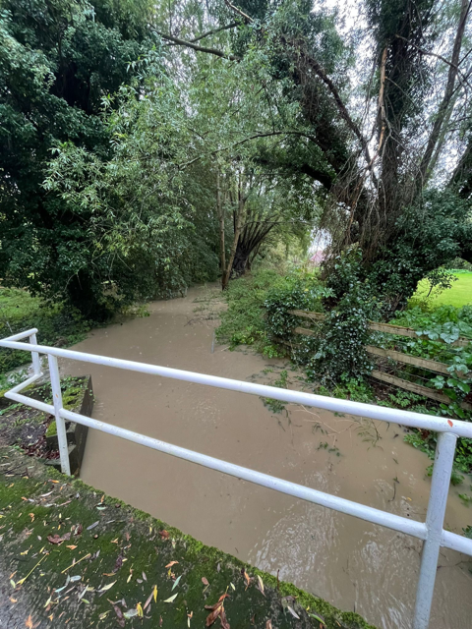

There was some water on the road in front of the Broad Marston Manor entrance, but the road was still passable. This water was mostly coming from the field opposite Cotswold View. A few years ago, the ditch on the right hand side (as you drive out of Broad Marston) was dug out and the soil used to build a bund in the field. This bund has now eroded and disappeared, and in my opinion this ditch needs digging out again, and the soil used to rebuild the bund. I will ask the Pebworth Parish Council to see if there any monies left from the Cala Homes Flood alleviation maintenance fund (£5000) to help clear this ditch. They paid for it last time to be done, and I would strongly recommend they do it again.

In Honeybourne again there was some water on the road outside the Gate pub but the road was still passable. There was water along the High Street too but it seemed to be coming from the ditch opposite the Gate Inn, and the ditch along the High Street. I had a meeting with WDC flood engineers, and they are going to ask for these ditches to be dug out by the landowners/community.
The huge flood plain downstream of Honeybourne built in the last 2 years held by thousands of gallons of flood water entering the village on that Friday 20th October.. So another flood alleviation scheme that has worked.

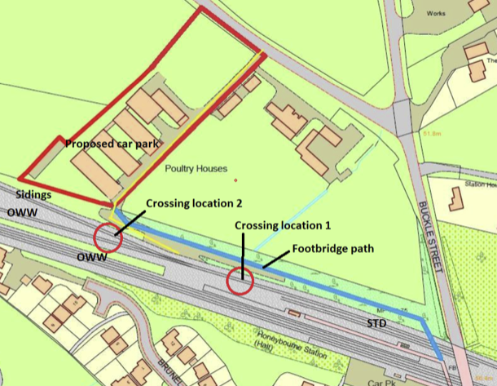
Network Rail gives the green light to the new Honeybourne Railway Station Car Park
WDC bought some land opposite the platform at Honeybourne Station just off Sheenhill Rd over 4 years ago to build a new railway car park with 200+ parking spaces. Unfortunately, Network Rail wanted £4million from WDC to connect to the existing pedestrian bridge so the project was put on hold. Over the last few years I have held several meetings with representatives from Network Rail and WDC, and started a campaign of writing to the CEO of Network Rail pushing for a cheaper option. The Parish Council, the MD of WDC, and our MP all wrote to the CEO. And at last we have some progress. NR have agreed that a pedestrian level crossing from the new car park to the platform can be constructed over the redundant rail track to Long Marston so the project can go ahead at a much-reduced cost. So hopefully the new Honeybourne Railway Station car park will be built in the next 12-18 months. See below map showing the proposed crossings.

Highways:
There are still some road and footway maintenance in progress in Worcestershire please check https://one.network/ to see all the temporary road closures on a regular basis. Also, please clear any debris off the road gullys near your homes to allow any rain to drain away.

- I have reported the sunken road opposite the entrance to Pebworth Nursery to Highways.
- Request to extend gritting route along Broad Marston Rd has been accepted by WCC. This will ensure there is a safe route for the school bus Chipping Campden. Awaiting the gritting routes to be updated on the WCC website.
- Dropped kerbs requested opposite 2, and 3, Chapel Road for mobility scooter. Awaiting survey and quote
- I have reported to Severn Trent the foul sewer manhole in School Rd which had foul water coming up through the manhole when we had the heavy rainfall recently.
- Flooding at Chalk Farm , Buckle Street – Culvert jetted, but some ditches still need to be dug out by the landowners/residents. Meeting arranged with WDC and residents.
- Noisy manhole cover opposite the Masons Arms – reported to Severn Trent to repair.
- Welford Bridge Closed
> Closure:
Mon 30th Oct - Fri 22nd Dec
(Foot & Cycle Access only)

> Christmas - bridge open
Sat 23 Dec - Mon 19 Feb

> Closure:
Tue 20th Feb - Wed 19 Mar
(Foot & Cycle Access only)

As always, if you have any issues on any Highways matters, please report it on the WCC website http://www.worcestershire.gov.uk/homepage/98/report_it
Also remember a photo of the Highways problem is as good as “a thousand words” so always take a photo where possible.
Ditches – IMPORTANT TO DIG OUT DITCHES TO REDUCE FLOODING
It is the land-owners responsibility to keep their ditches working correctly. At this time of year all ditches should be inspected and where necessary dug out. The bottom of any pipes that feed into the ditches must be clear, and the bottom of the pipe should be above the bottom of the ditch.

Earlier this year a house in Dorsington Rd was flooded at junction with Long Marston Rd. The cause was unmaintained ditches. The good news is the ditches have now been dug out by Heart of England Forest, and all the culverts under the road checked and jetted. On Friday 20th October this house was not flooded. So please keep your ditches clear.

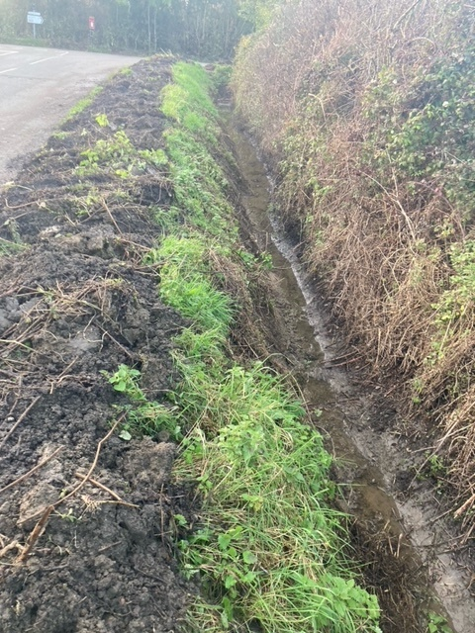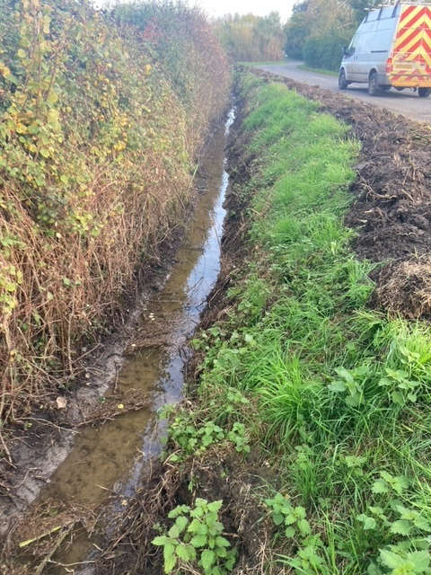

County Council Divisional Fund

Applications for the Divisional Fund are invited from local community organisations that are manned by volunteers and require a little help to buy equipment or services. To apply, please contact me on adams.pebworth@gmail.com
The following grants have been requested, and some have already been approved & paid
- Honeybourne Village Hall – grant to help provide a Senior Citizen lunch for the Coronation
- Honeybourne School – grant to help build a “Growing Hope” garden
- Honeybourne Bowls Club – grant for a contribution towards a new mat
- Cleeve Prior Heritage Trust – grant for new tables
- Pebworth Bells – grant to help improve their Website
- Freedom Day Centre – grant for a defibrillator
- Cleeve Prior Art Club – grant for portrait training
- Coffee Mornings in Pebworth Village Hall – grant requested for soup kettle and hall hire
- Offenham Cricket club – grant towards an artificial wicket for training
- Honey Tots Playgroup, Honeybourne – grant requested for some play equipment

Latest news from our local Police Team – see below
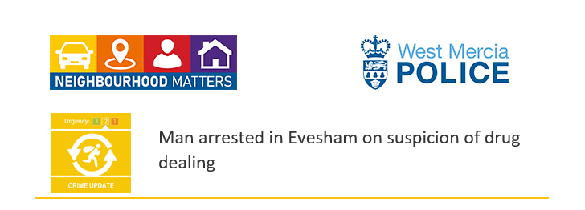

Officers have today (Wednesday 25 October) arrested a 42-year-old man in Evesham on suspicion of possession of class A drugs with intent to supply.

At 10am this morning members of the Neighbourhood Crime Fighting Team (NCFT) were on patrol in Evesham High Street when their attention was caught by a suspected drug deal taking place.

Police approached a suspected dealer on a moped who attempted to drive off, but they managed to stop the driver.

A 42-year-old man, who is currently in police custody, was arrested on suspicion of possession of class A drugs with intent to supply for failing to stop for police, driving whilst unfit through drugs, dangerous driving, and driving with no insurance.

Over 100 wraps of suspected class A drugs as well as class C drugs were seized by police.

Sergeant Shaun Blackshaw from the NCFT has said “This was a great proactive stop by officers in Evesham.

“I am keen for the benefit of the NCFT to be felt across the whole of South Worcestershire.

“With the assistance of local Response and Safer Neighbourhood Team units, police have seized a moped and recovered a significant quantity of drugs off our streets.

“Drugs ruin lives with the consequences far-reaching and we will not hesitate to disrupt the criminal behaviour of those suspected of being involved.”

“I urge members of the public to report any suspicious behaviour to us via 101 or on our website at Report a crime | West Mercia Police and we will proactively target these areas to stop offending.”

To make a report of a crime or incident, please contact West Mercia Police at www.westmercia.police.uk or dial 999 in an emergency, or 101

Your County Councillor, Alastair Adams can be contacted on adams.pebworth@gmail.com or mobile 07725 979 277 or www.alastairadams.org

APPENDIX C – VAS DATA

