 | On the beat in  Evesham  Safer Neighbourhood Team Newsletter | Spring  2024

Welcome to your latest newsletter from the Evesham Safer Neighbourhood Team. As always, we have some good news stories to share with you and information about what the teams have been up to over the last quarter.

Community Priorities

Once again thank you for those Parishes who have returned their priorities for the last quarter. By returning these to us we can identify Community priorities and then aim to focus our attention on the main concerns. Speeding is one of the main concerns and the teams will get out and do enforcement when time allows. If you are having issues with Speeding in your area, require any guidance or want to know how we can assist you further then please contact the Road Safety Team at roadsafety1@westmercia.police.uk or your local SNT team on the relevant email address listed at the bottom of the newsletter.

Shop Watch / Street Watch Schemes – Broadway

Shop Watch schemes are partnerships between your business, the police and others such as local authorities to support communities against retail-related crime We understand the devastating impact that crime can have on a business, which is why we want work together and help our local communities. They aim to:
- help prevent and detect crime in communities.
- find long-term solutions to local problems.
- provide a visible policing reassurance to local businesses.
- improve the communication flow between communities and the police.
- reduce and prevent criminality and antisocial behaviour.
- reduce the fear of crime by helping solve your crime-related problems.

Street Watch is a scheme that will give you the opportunity to help keep your local area safe, by walking around your neighbourhood and working with your local policing team to report any crime or anti-social behaviour that you may see.

Both schemes have been successfully implemented by PC Ben Trowman in Broadway with the majority of shops and establishments signed up and also two volunteers for Streetwatch. Find more information on watch schemes here: https://www.westmercia.police.uk/advice/advice-and-information/wsi/watch-schemes-initiatives/
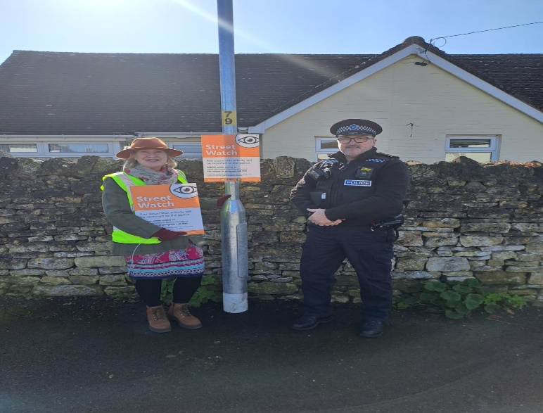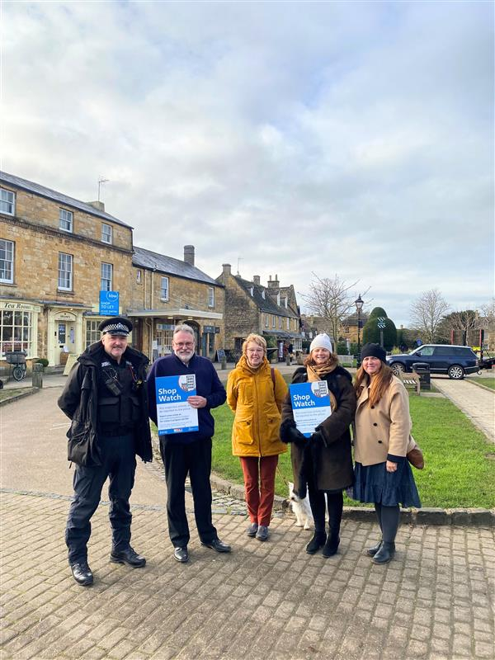

Good News / Results

Town Centre officers have been on regular high visibility patrols in Evesham targeting shop theft, Anti-Social behaviour and Drugs. This has led to more than 15 arrests that the team have been involved with, including breaches of bail, drug possession, criminal damage and a number of prolific shoplifters, including one that the team successfully applied for a Criminal Behaviour Order on.

One of the teams’ priorities is to reduce shop theft. This has meant that we have been targeting our repeat and prolific offenders and working with businesses and local agencies to achieve this in a partnership approach. Spending more time on the streets and with our communities. We have also set up the shop watch scheme within the town.

Further good news is that the PCC has announced additional officers for Evesham Town Centre. These additional officers will be arriving later in the year, and we will hopefully introduce them on the next newsletter.

Campaigns

We have seen County Lines Intensification week which focuses on tackling County Lines drugs Forcewide. This resulted in the Neighbourhood teams undertaking a number of actions including a significant amount of intelligence being submitted, numerous visits to houses in Evesham which had been previously targeted by county lines to provide them with reassurance, advice and Safeguarding. During this week we also visited the schools on our area to provide them with posters and inputs on knife crime to raise awareness. Plain clothed and hi visibility patrols were also conducted in the hotspots that dealers frequent to try and disrupt them. Arrests involving those involved in bring drugs into Evesham were also conducted by our Proactive team.

Please remember that if you have concerns around drugs and drug supply, you can contact the Police to report this or use Crimestoppers which is anonymous.
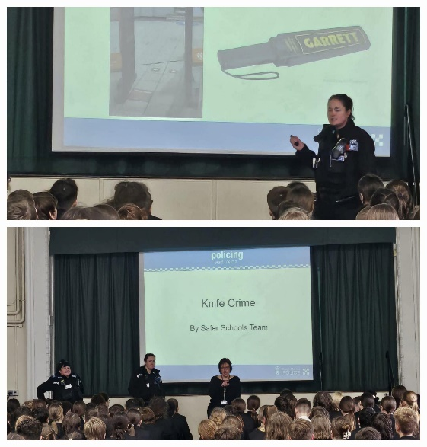
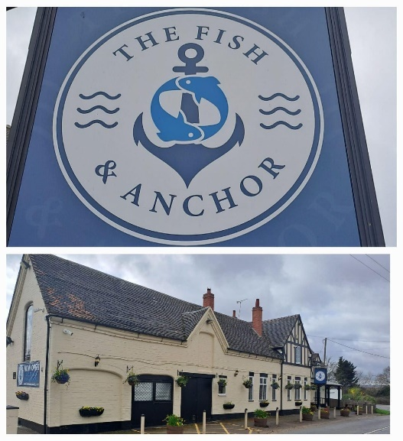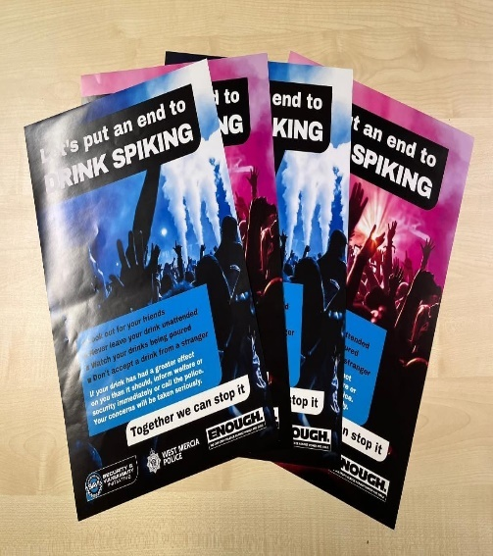
Anti-Spiking Week of action in March the team were out engaging with the local pubs and clubs regarding spiking. The pubs were issued with the Anti-spiking posters for them to display inside the venue. They were also provided with Anti-spiking devices for any bottled drinks they sell. All engaged well with the police and supported the initiative. The Fish and Anchor, Offenham is the first pub in Wychavon to sign up to the LSAVI Initiative, to make venues safer for customers, read more here: https://www.westmercia.police.uk/news/west-mercia/news/2024/march/join-the-pubs-and-clubs-already-being-licensing-savi-and-help-make-venues-safer/

E-Scooter Education & Campaign - The campaign, in partnership with Wychavon Council, follows community concerns in the district where people have been seen using the electric powered vehicles on the street.

PC Justine Lane, PC Martin Kennedy and other SNT officers have been visiting local schools where they were able to educate both pupils and teachers about the use of e-scooters. During the sessions students engaged with officers, asked questions, and took on board everything discussed.

The team have also been engaging with local business and members of the community and retailers around the illegal use of these scooters. This work will continue along with appropriate enforcement. Please contact the team if you need further information. Please see information at end of newsletter.

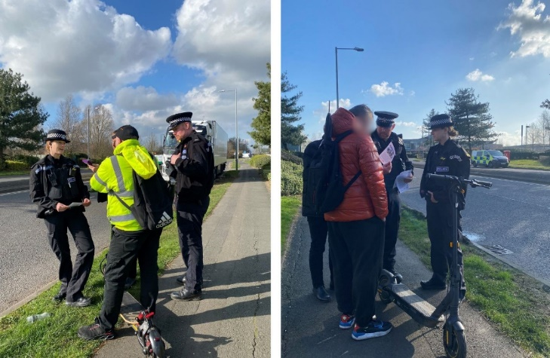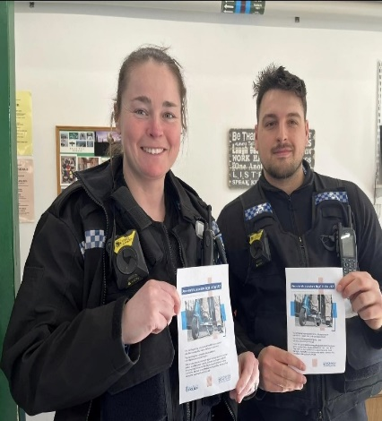
Community Engagement

There have been so many Engagements within Communities and schools this quarter, here are a few highlights:
Crime and Punishment – St Andrews School - Year 5 had two special visitors, PC Martin Kennedy and PC Justine Lane from our local Safer Neighbourhood Team.
Easter Rooftop Event aiming to bring together different communities of Evesham.
Cavendish Park Care Home Autism Awareness Event.
Crime Prevention Events in collaboration with Wychavon District Council & bike / property marking.

If you have any engagements, you would like us to take part in, or ideas on how to engage and feedback with your community then pleas get in touch with us on the SNT emails at the bottom of this newsletter.

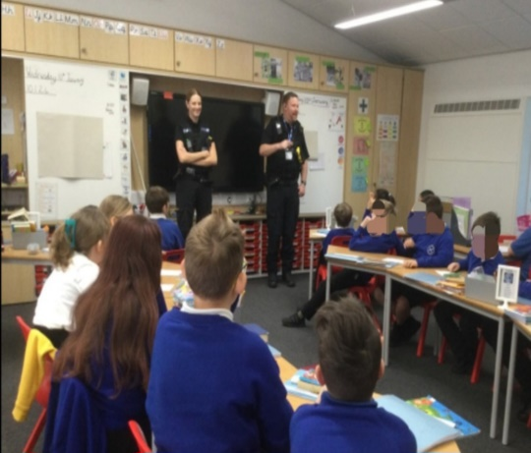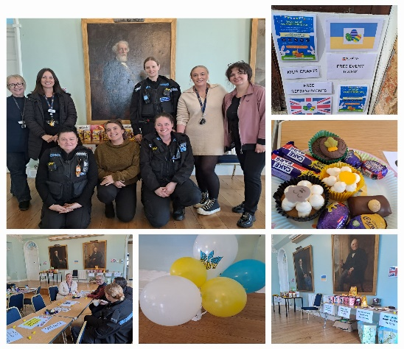
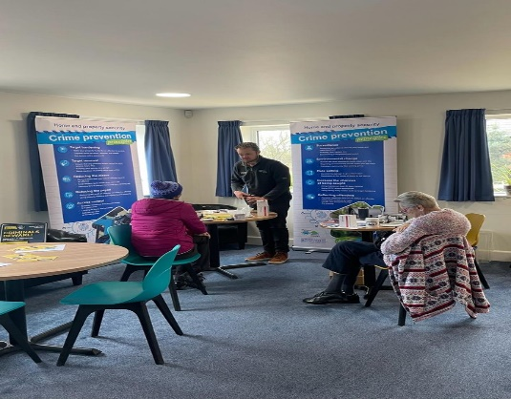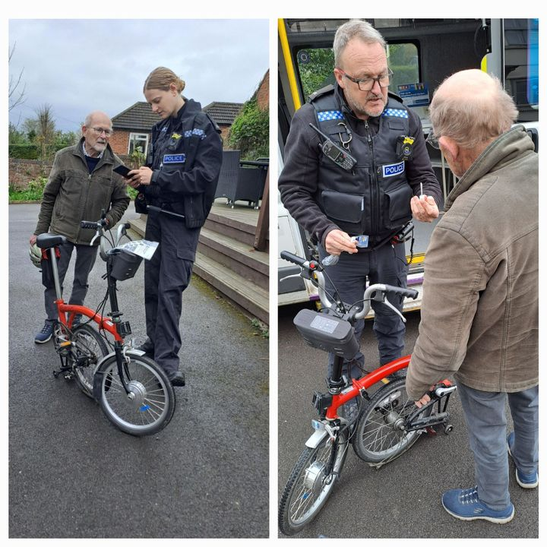

Useful Information

You can use the below link to report ASB to West Mercia Police.

Report antisocial behaviour | West Mercia
Police.

For crimes in progress call 999.
For non emergencies report online:www.westmercia.police.uk/report or call 101 for the non emergency line

Email the teams:
Evesham Rural North eveshamrn.snt@westmercia.police.uk
Evesham Town North and Rural South eveshamtnrs.snt@westmercia.police.uk
Evesham Town South and Rural West eveshamtsrw.snt@westmercia.police.uk

Please do not email the teams to report crime or incidents.

Your local policing teams are also actively involved with the below Social media accounts, please follow them for updates on our work, and local events/news. https://www.facebook.com/EveshamSNT/


If you aren’t comfortable contacting us directly, you can pass on information anonymously to the independent charity, Crime stoppers, by calling 0800 555 111 or by visiting their website: www.crimestoppers-uk.org

Sign up to Neighbourhood Matters … your community messaging service
 | Neighbourhood Matters enables residents, businesses and community groups to keep in touch with local policing teams. You can choose exactly what type of alert you wish to receive and how you receive them; whether that be by email, text or telephone.  Sign up now at: www.neighbourhoodmatters.co.uk

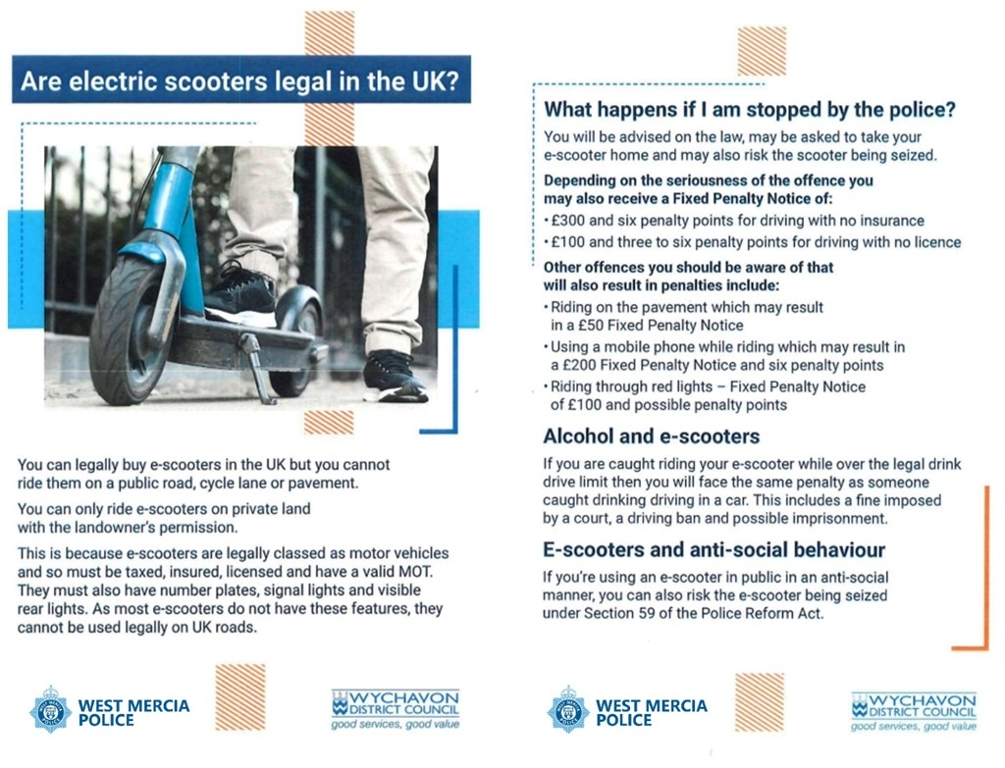

For the latest crime prevention advice visit: www.westmercia.police.uk/cp/crimeprevention/

