


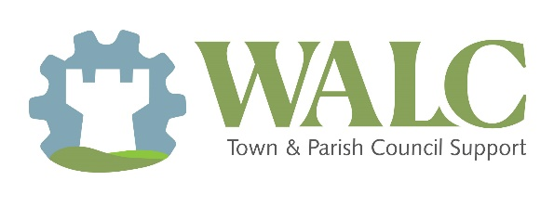


Draft Motion for Councils: Future of Neighbourhood Planning Support Services
Resolution Calling on the Government to Provide Dedicated Funding for Neighbourhood Plans

[Insert name of Council] acknowledges that:
- Neighbourhood planning empowers local communities to shape the development and growth of their areas through the creation of Neighbourhood Plans.
- The preparation of Neighbourhood Plans requires significant time, expertise, and financial resources, often placing a burden on parish and town councils.
- Neighbourhood Plans contribute to more democratic, locally-informed planning decisions and support the delivery of sustainable development aligned with community needs and aspirations.

Therefore it is Resolved to -
- Call upon His Majesty’s Government to provide increased and sustained funding to support the development, review, and implementation of Neighbourhood Plans.
- Request that the Government ensures funding is accessible to all communities, to promote inclusivity and fairness in the planning process.
- Write to [local MP] and the Secretary of State for Housing, Communities, and Local Government to communicate this resolution and advocate for enhanced support for neighbourhood planning

